Implementation of IaaS

**Create EC2 (Elastic Compute Cloud) Instances:**

1. Visit <https://aws.amazon.com>
2. Go to **My Account** Section at Top Right Corner.
3. Click on **AWS Management Console** & Enter your login credentials.
4. If you want to create account then click on **Create an AWS Account**.

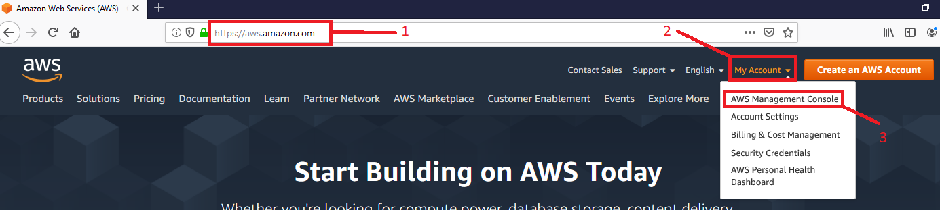

1. After Login, select **Services**.
2. Click on **EC2** to launch an EC2 instance(Virtual Machine).

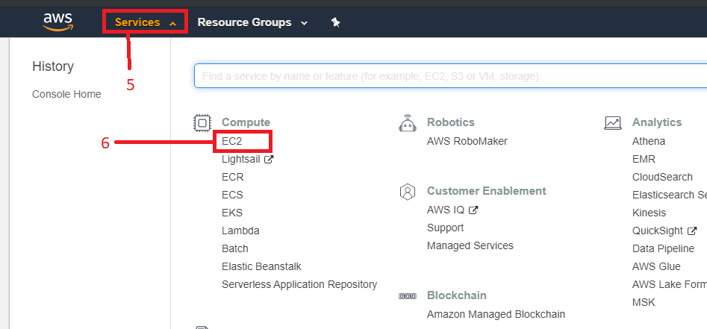

1. Click on **Launch Instance**.

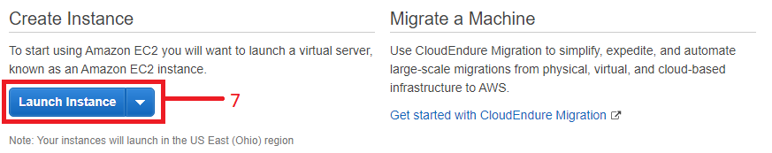

1. Tick on **Free tier only** checkbox.
2. **Select** any operating which you want to launch.

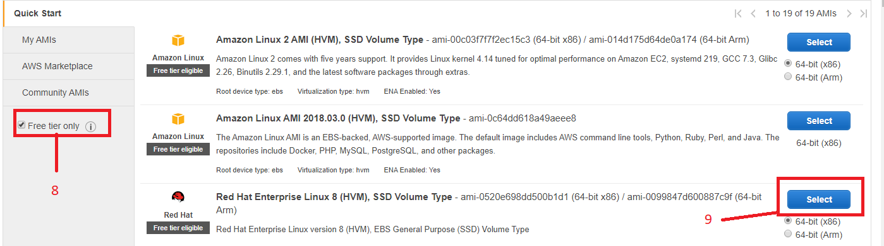

1. Select instance type **t2.micro** because it is free to use.
2. Click on **Next: Configure instance Details**.

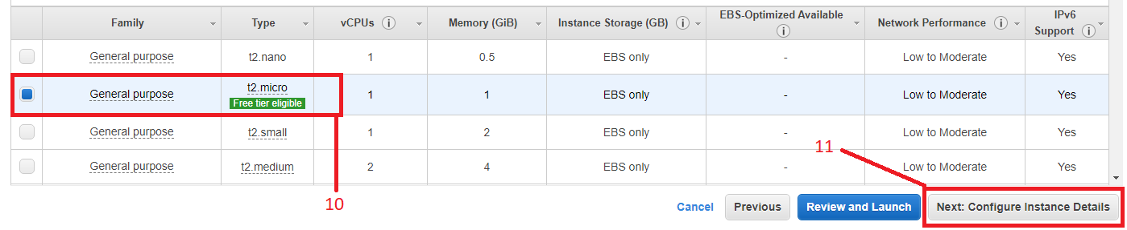

1. Enter how many instances(VMs) you want to create in **Number of instances**.
2. Click on **Next: Add Storage.**

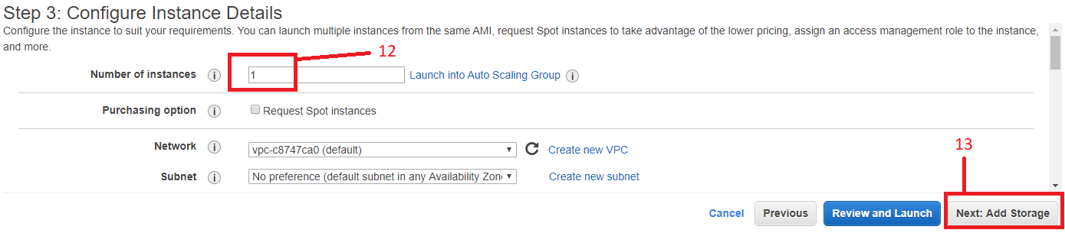

1. Enter Size which you want to give to the VM don’t enter size less than default because it automatically selects minimum required space required to launch the instance**.**
2. You can also add new storage Volume from Add **New Volume** option, It is optional.

(Note: Don’t use Total volume size more than 30GB, otherwise AWS will charge amount for it.)

1. Click on **Next: Add Tags**.

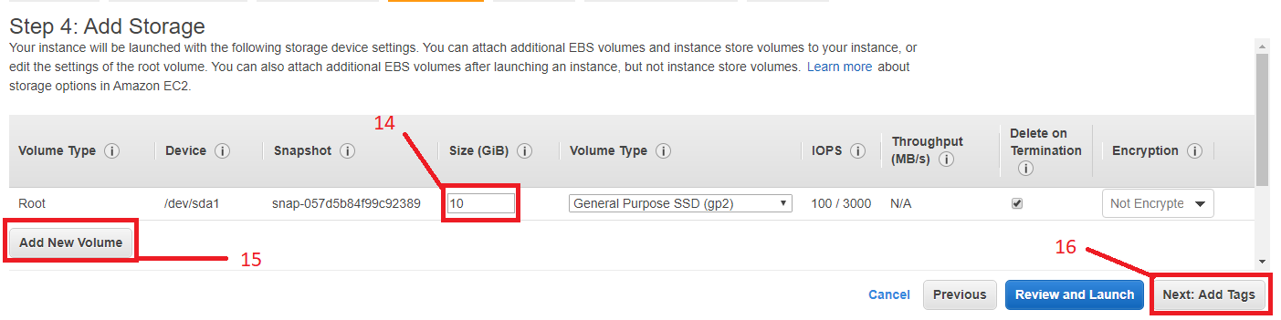

1. **Add Tag**, It is an optional part. If you want to add tags for your reference then you can add it.
2. Click on **Next: Configure Security Group**.

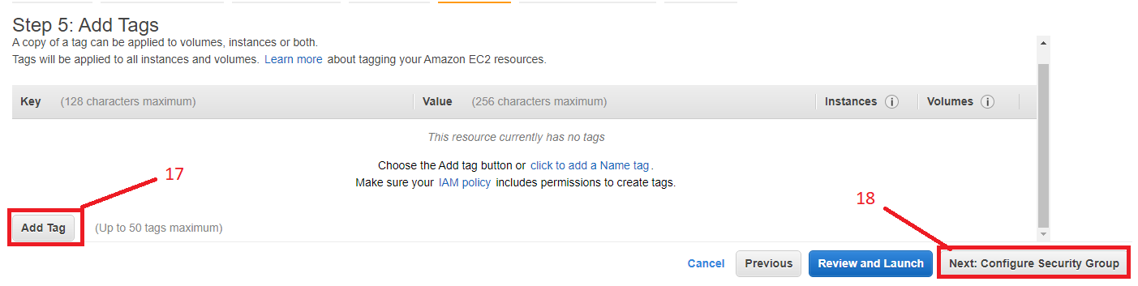

1. If you want to create new security group then select **Create a new security group** option. And enter new name in **Security group name:** option as well as give description to it.
2. If you have already created security group before then tick on **Select an existing security group** and choose that group.
3. It is important part for security and accessebility of instance. If you are creating instance based on Linux kernal such as Red Hat, CentOS, Ubuntu then you must nîd to add **SSH** here and for windows **RDP**. You can also allow **All traffic** if you want to turn ON all ports.
4. In **Source** option you can specify IP from where your instance / it’s allowed ports will be accessible. If you have Selected **Anywhere** option here then your instance or it’s allowed services will be accessible globally.
5. If you have selected All Traffic option from step 21 then no need to click on this. You can allow multiple ports by **Add Rule** option.
6. Click on **Review and Launch** after Creating or selecting security group.

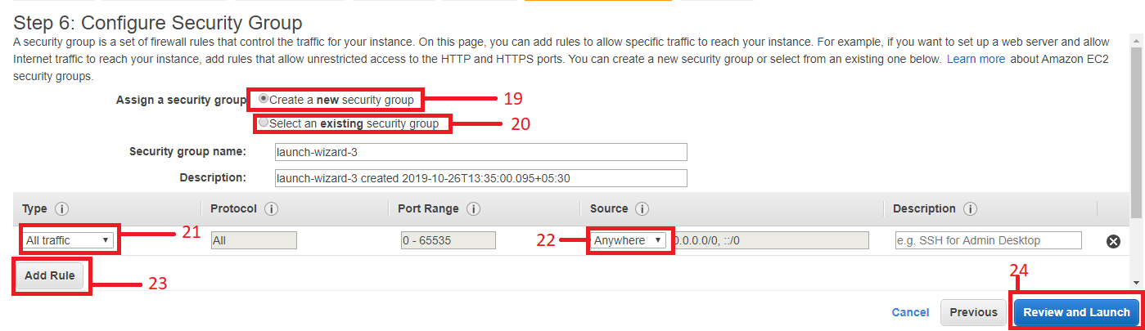

1. Review configuration which you have done and **Launch** the Instance.

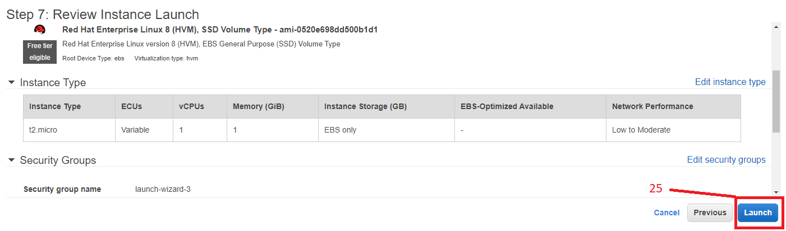

1. Creating a key pair is important step in EC2 without key pair you cannot access the instance. If you have already created key before and stored it on local computer then there is no need to create new one you can use one key to access multiple instances. If you want to create a new key then select **Create a new key pair** option, give it a name and download it.
2. **Lauch Instances** and Therefore click on **View Instances** button to view and modify instance details.

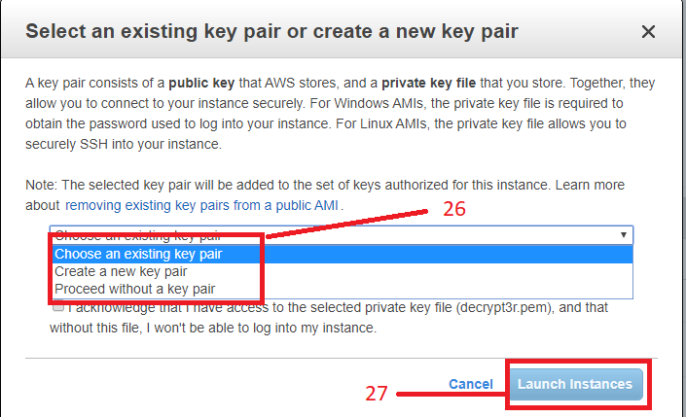

By these steps you can easily launch ec2 instance. For launching Windows instance all steps are same like launching Linux instance, only in step 9 you need to select Windows Image. But while accessing the instances there are different steps for windows and Linux. To access Windows Instance we need to take **RDP** (Remote Desktop Protocol) Session. To access Linux based instance you need to take **SSH** (Secure Shell) access.

**How to access EC2 Instance (Linux):**

If you want to access Linux based instance then you need to download external software to take SSH access. Windows operating system supports key pairs in .ppk format but ec2 creates key in .pem format so we need to convert it using puttygen software and you can access instance using software’s like putty, mputty. There is also alternative software available for which not need to convert key format **- Mobaxterm**.

1. Download and extract mobaxterm and run executable file.

Official site to download mobaxterm: <https://mobaxterm.mobatek.net/>

1. Skip step-2, step-3 & step-4 and go to step-5 if you have already clicked on **view instance** button. Otherwise Click on **Services** option.
2. Select **EC2**.

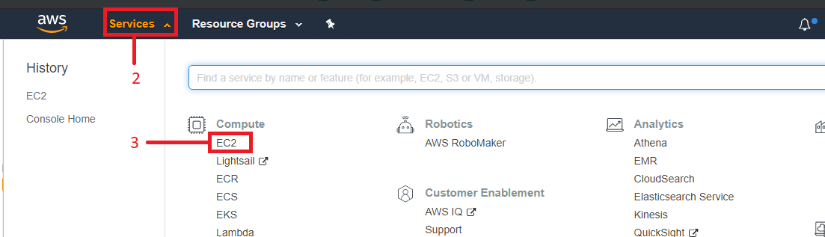

1. Click on **Running Instances**.

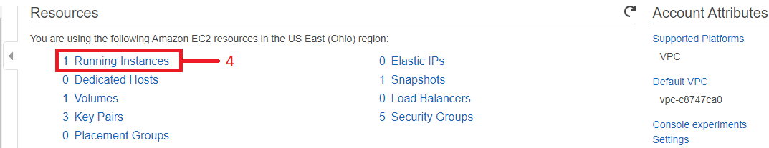

1. Select checkbox of instance which you want to access. You can also set Name for that instance in Name Panel.
2. Copy **IPv4 Public IP** of the instance. (Try to access VM when Instance State and Status check is green.)
3. Click on a **Connect** option to know the username.

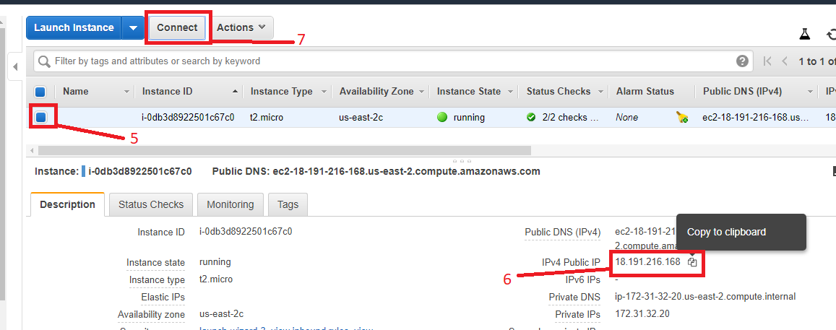

1. Know username for the instance which is after key pair name and before @ in Example.
2. **Close** the Connect Option.

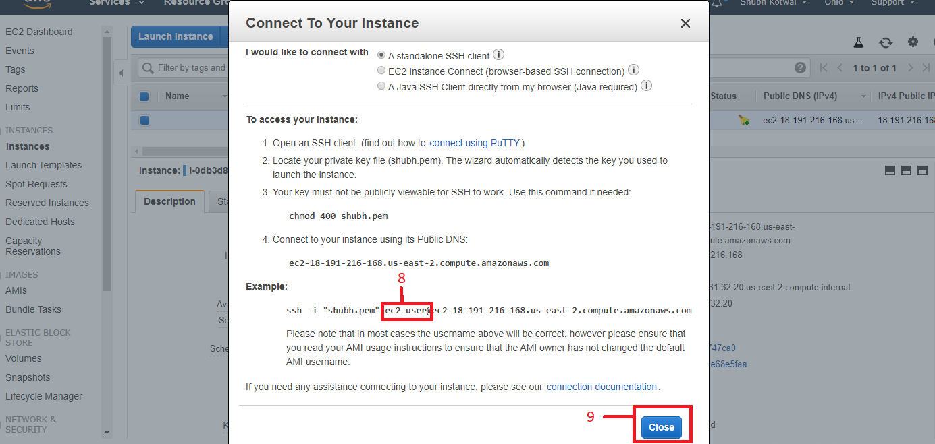

1. Open downloaded Mobaxterm software. And click on **Session**.

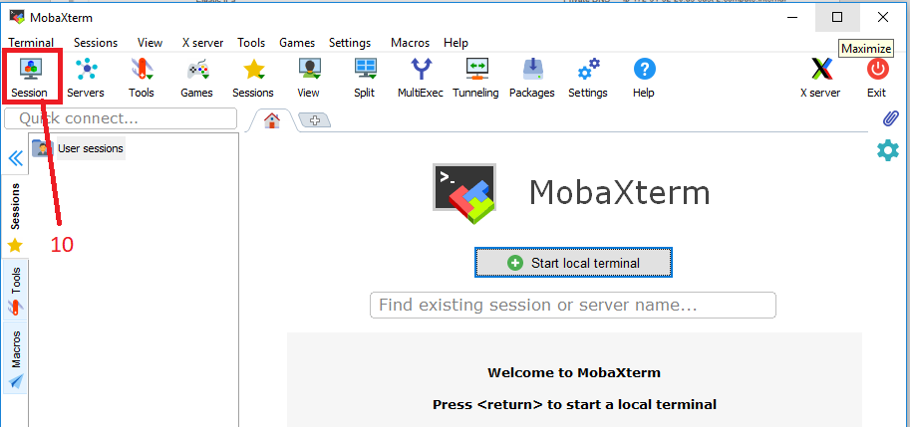

1. Select **SSH** Button.
2. Paste Copied Public IPv4 Address of Instance (Step 6) in **Remote host**.
3. Tick on **Specify Username**.
4. Enter Username (Step 8)
5. Click on **Advanced SSH settings**.
6. Tick on **Use private key**.
7. Select Key from location where you have downloaded (Create Instance Step 26). And click on **OK**.

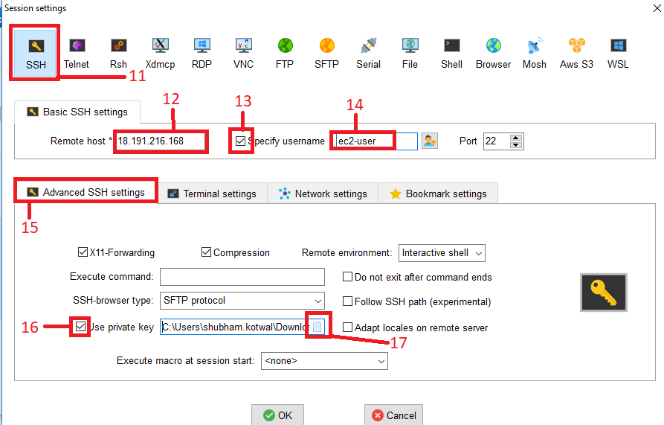

1. You have successfully accessed EC2 Instance. Use command ***sudo –i*** to use instance as a root (Administrator/Super User) user.

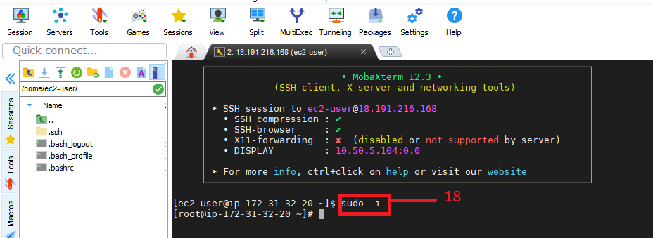

**How to access EC2 Instance (Windows):**

To access the Instance, follow step-1 to step-6 same as Linux. Then:

1. Select Instance which you want to access.
2. Copy IPv4 Public IP.
3. Click on **Connect** Option.

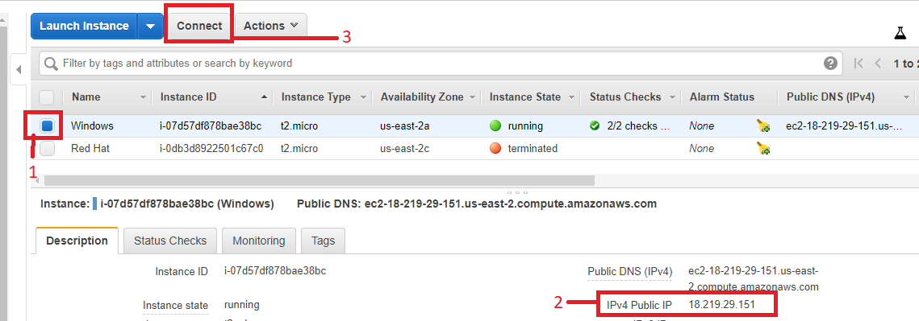

1. Username for the Instance will be display here.
2. Click on **Get Password**.

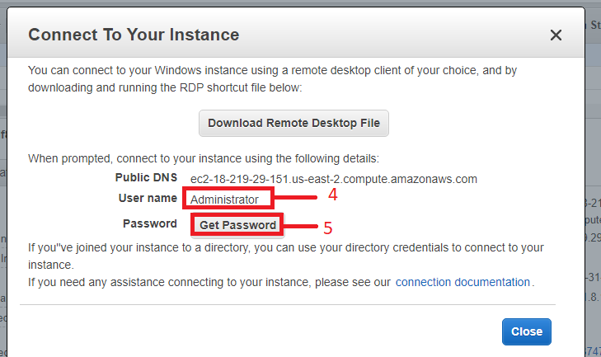

1. In **Choose File** option select downloaded key pair in your local PC (Create Instance Step 26).
2. Click on **Decrypt Password.**

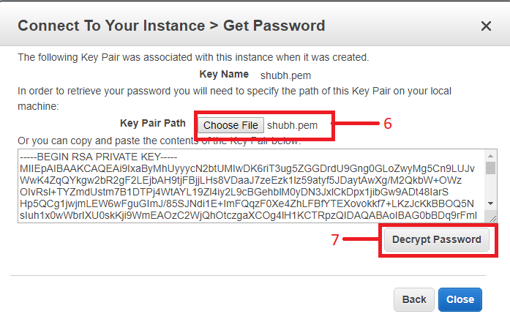

1. Here you will get login credentials (Username and Password) for your instance.

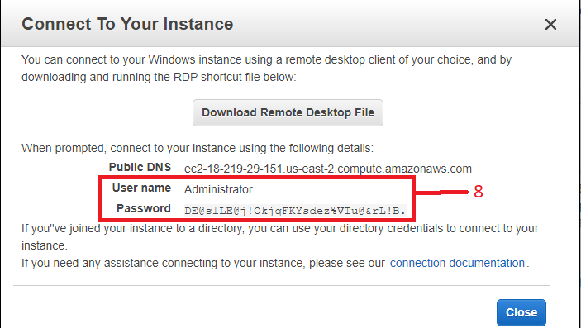

1. Hit Win+R shortcut and enter **mstsc** in Windows or search for Remote Desktop Connection in Windows Search menu (Bottom Left Corner). And click OK.

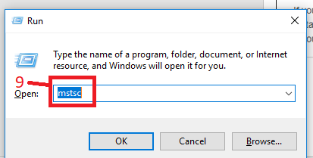

1. Paste copied Public IPv4 address (In Step 2).
2. Click on **Show Options**.

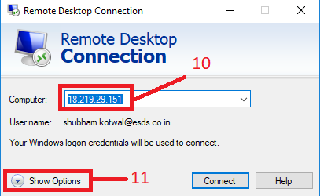

1. Tick on **Always ask for credentials**.
2. Enter **Username** (Step 8).
3. Click on **Connect**.

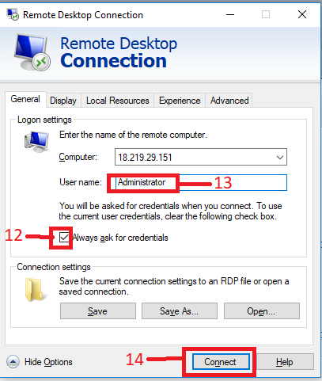

1. Enter password of the Instance (Step 8).
2. Click on **OK** Click yes to approve certificate and you will get RDP access of the Instance**.**

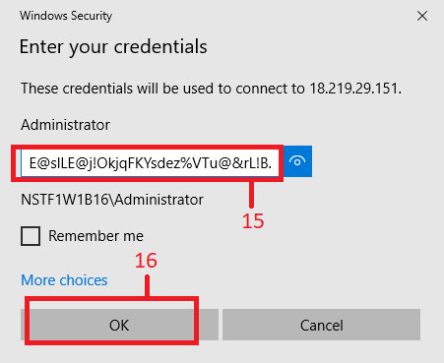

**How to Terminate Instance:**

By terminating the instance you will lose all the work you did on the instance. If you want to take snapshot of the instance in present state then you can create image of the Instance.

1. Select Instance which you want to terminate.
2. Click on **Actions** button.
3. Click on **Instance State**.
4. Click on **Terminate** and after that click on **Yes Terminate** button.

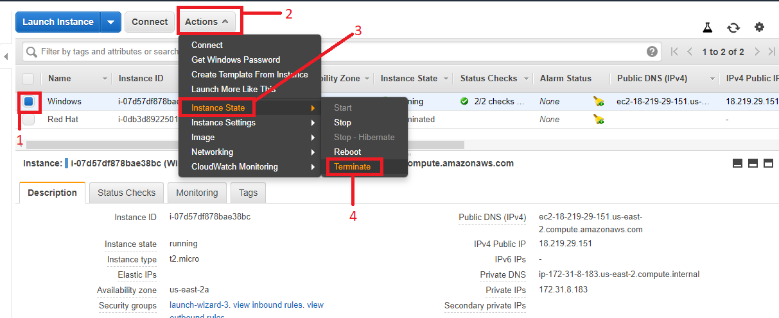

**How to set or remove Termination Protection on Instance:**

By adding termination protection no will be able to terminate the instance until disabling the protection.

1. Select Instance on which you want to set termination protection.
2. Click on **Actions.**
3. Select **Instance Settings**.
4. Click on Change **Termination Protection** andenable/disable protection as you want.

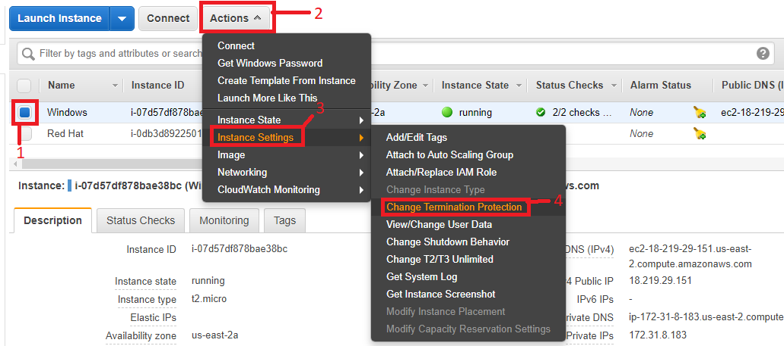

**How to create Image (Snapshot) of Instance and launch instance with same configuration from that image:**

This will save all the settings and configuration done on the instance till present time.

1. Select Instance of which you want to take snapshot.
2. Click on **Actions**.
3. Select **Image**.
4. **Create Image**.

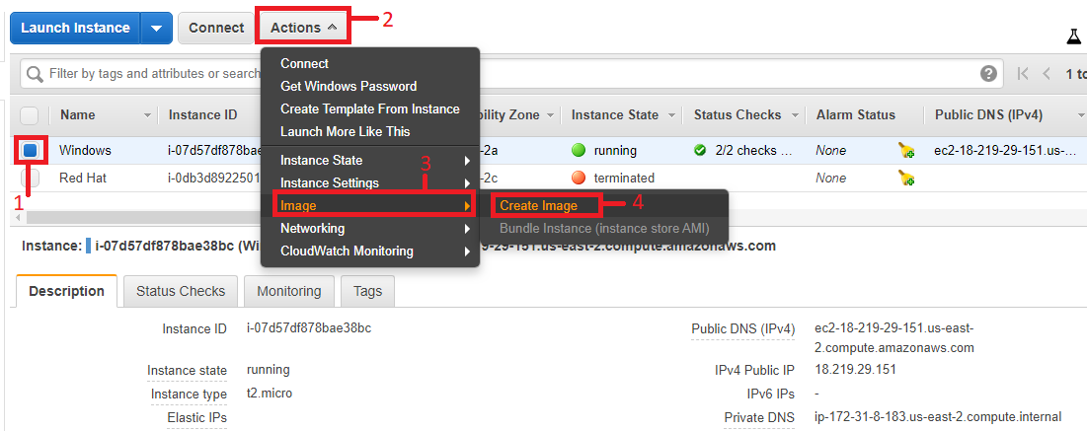

1. Enter any name for the Image.
2. Enter **Image Description**.
3. Click on **Create Image**.

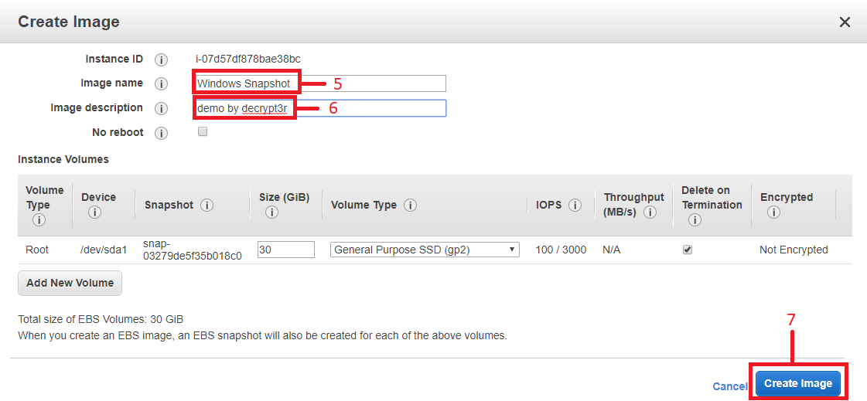

1. Click on AMIs option from left screen which is Under Images Drop down Menu.

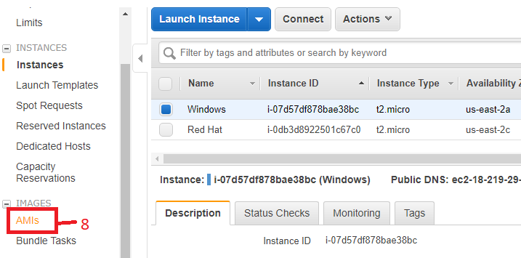

1. Wait until Status become available. And simply select image and click on launch to create new instance from that Image.

